January 28, 2019

Install PostgreSQL
sudo apt update
sudo apt install postgresql postgresql-contrib
sudo -u postgres createuser --interactive // use your account name and make it a superuser
sudo -u postgres createdb <account-name>

command line
$ psql = goes into the psql environment like node for javascript
$ psql < sql_lab.sql = this loads up the databse from script sql_lab.sql
$ psql -d sql_lab = this connects with the db sql_lab when you go into node
to get out of psql ‘\q’

in pSQL command
$psql -d sql_lab go into psql with the sql_lab environment
$ psql -d sql_lab < sql_demo.sql = run script file sql_demo.sql in the database sql_lab
$ \dt = shows a list of the tables
$ \d <table name> = describes table fields and keys of cars db
$ \i sql_demo.sql = executes .sql script file in the same directory

$ \q = quits psql

$ select * from students
$ SELECT id, first_name, last_name FROM students;

Data types that can be used in postgreSQL

https://www.postgresql.org/docs/9.5/datatype.html



SELECT * FROM students WHERE id > 100;

JOINS

inner join

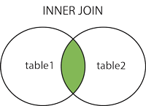

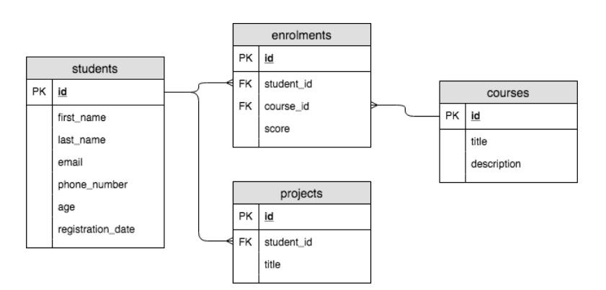

SELECT * FROM students
WHERE registration_date > NOW() - INTERVAL “280’ DAY;

-- SQL: BASICS

-- Comments

-- <- A single comment

/*
<- A multi-line comment
*/

-- CREATING A TABLE

-- For a list of all available COLUMN data types, go to:
-- https://www.postgresql.org/docs/11/datatype.html

-- CREATE TABLE cars (
-- id BIGSERIAL,
-- /*
-- [BIG]SERIAL is a special data type unique to PostgreSQL.
-- It creates an BIGINT that is auto-incremented. When insert
-- a new row, we'll not specify this column ourselves.
-- We call this `id` the PRIMARY KEY. It acts as a unique
-- identifier for rows.
-- */
-- make VARCHAR(50),
-- /*
-- The VARCHAR(<char-max>) is a string stype with
-- specifiable maximum number of characters.
-- */
-- model VARCHAR(255),
-- doors INTEGER,
-- /*
-- The INTEGER is a number type that can't have decimal
-- values. However, it can be negative.
-- */
-- description TEXT
-- /*
-- The TEXT type is string that can be of any length.
-- */
-- );

-- ALWAYS terminate SQL queries with a `;`. This is
-- NON-NEGOTIABLE. If you forget it, SQL will that you're
-- still writing your query.

/*

To run this or any other sql files, do the following:

psql -d <db-name> < <path-to-sql-script>

To run the file from `psql`, do the following:

psql -d <db-name>

\i <path-to-sql-script>
*/

-- CRUD OPERATIONS

-- CREATING ROWS (OR INSERTING ROWS)
-- https://www.postgresql.org/docs/9.5/sql-insert.html

/*
INSERT INTO "students"
("first_name", "last_name", "email", "phone_number")
VALUES
('Jon', 'Snow', 'js@winterfell.gov', '778.994.8776');

INSERT INTO "students"
("first_name", "last_name", "email", "phone_number")
VALUES
('Cersei', 'Baratheon', 'cersei@kingslanding.com', '778.994.9999')
RETURNING *;
*/

-- READING DATA

-- This will get all rows from the students table
-- display all columns.
-- SELECT * FROM students;

-- This will get all rows from the students table
-- displaying only the columns: id, first_name and
-- last_name
-- SELECT id, first_name, last_name FROM students;

-- USE WHERE STATEMENT TO FILTER YOUR DATA

-- This will get all students that have an "id" column
-- of 1.
-- SELECT *
-- FROM students
-- WHERE id = 1;

-- Select all students whose ids are more than 100
-- SELECT id, first_name
-- FROM students
-- WHERE id > 100;

-- Select all students that have registered in the
-- last 280 days
-- https://www.postgresql.org/docs/9.1/functions-formatting.html
-- https://www.postgresql.org/docs/9.1/datatype-datetime.html

/*
SELECT id, first_name, registration_date
FROM students
WHERE registration_date > '2018-04-23';

SELECT id, first_name, registration_date
FROM students
WHERE registration_date > NOW() - INTERVAL '280' DAY;

SELECT id, first_name, registration_date
FROM students
WHERE registration_date > CURRENT_DATE - INTERVAL '280 days';
*/

-- USING AND/OR

-- Select all students whose ids are more than 100 and
-- less than 200

/*
SELECT id, first_name
FROM students
WHERE id >= 100 AND id < 110;

SELECT id, first_name
FROM students
WHERE id BETWEEN 100 AND 110;
*/

-- Find all students whose "created_at" is NULL

/*
SELECT id, first_name, created_at
FROM students
WHERE created_at IS NULL;

SELECT id, first_name, created_at
FROM students
WHERE first_name = 'Jon' AND created_at IS NULL;
*/

-- WILDCARD LIKE & ILIKE

-- Find all students whose first names begin with
-- 'Jo' (case sensitive)

-- SELECT id, first_name
-- FROM students
-- WHERE first_name LIKE 'Jo%';

-- Select all students whose first_name or
-- last_name contains 'nn'

-- SELECT id, first_name, last_name
-- FROM students
-- WHERE first_name ILIKE '%nn%' OR last_name ILIKE '%nn%';

-- ORDERING RESULTS
-- LIMIT RESULTS

-- SELECT id, first_name, last_name, age
-- FROM students
-- WHERE age IS NOT NULL
-- ORDER BY age DESC, last_name ASC
-- LIMIT 25; -- First 25 rows only

-- OFFSET RESULTS

-- SELECT id, first_name, age
-- FROM students
-- ORDER BY age ASC
-- LIMIT 10 -- Limit to 10 rows displayed
-- OFFSET 30; -- Skip first 30 rows

-- OFFSET combined with LIMIT can be used to implement
-- pagination

-- AGGREGATE FUNCTIONS
-- Use these to do calculations on combinations
-- of your data
-- For a full list of functions, checkout:
-- https://www.postgresql.org/docs/10/static/functions-aggregate.html

-- SELECT
-- COUNT(*) AS students_count,
-- ROUND(AVG(age), 3) AS average_age,
-- SUM(age) AS total_age,
-- MIN(age) AS youngest_students_age,
-- MAX(age) AS oldest_students_age
-- FROM students;

-- Sometimes we want to do aggregate calculations
-- on groupings of rows in our tables. Use GROUP BY.

-- SELECT COUNT(*) AS occurences, first_name
-- FROM students
-- GROUP BY first_name
-- ORDER BY occurences DESC;

-- UPDATE A ROW

-- UPDATE students
-- SET first_name = 'Something Else'
-- WHERE id = 1
-- RETURNING *;

-- DELETE

-- DELETE FROM students
-- WHERE id = 502
-- RETURNING *;

